STAT3011 Report — Further Investigation (Group 23)
- To refine our outlier detection process, we additionally use the interquartile range with a coefficient of 3.5 before modeling to remove extremely small and large values. This ensures subsequent model training can avoid interference from extreme data.
- We found that all data lie within the limit and the data size did not change.
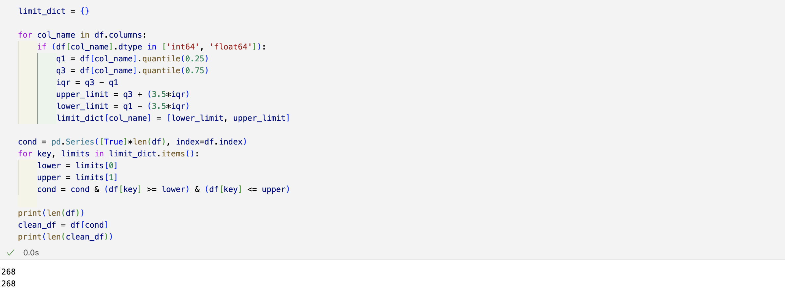
- For model selection, alongside the IForest model, we also modeled the LOF and KNN models.
- To build the LOF model, we first do the hyperparameter tuning for each model by comparing RMSEs. After comparing different values of n_neighbors and metrics, we find that (20, 'euclidean') produces lowest RMSE.
- Then we fit the data using hyperparameters found before, with 6 outliers detected.
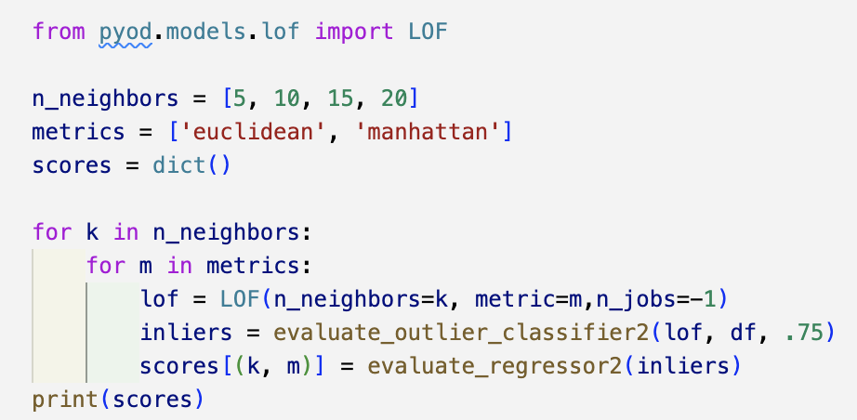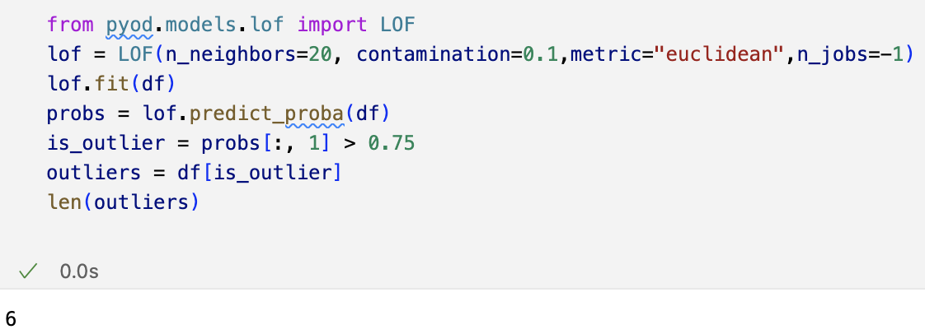
- For KNN model, we also selected more appropriate parameters by comparing the RMSE score of outputs across different parameter values.
- We compared different choices of n_neighbors value and found that when n_neighbors was set to 10, the RMSE was minimal.
- We also compared different values for p and method, discovering that p=4 and method="median" are optimal choices.
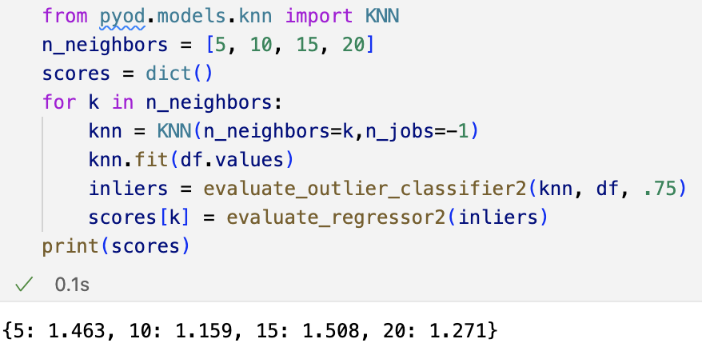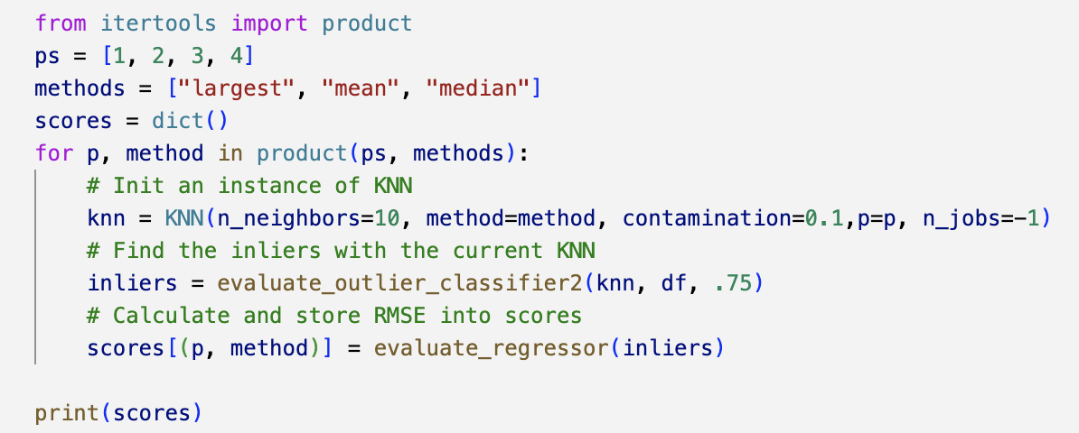
- After selecting the more suitable value for parameters, the number of detected outliers of KNN model was 22.
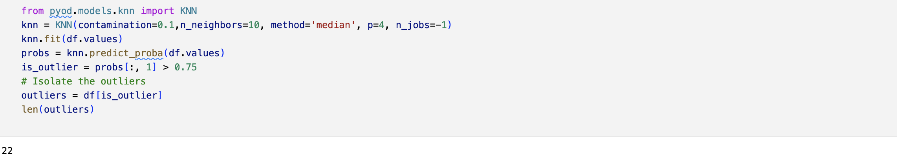
- Since the three models identified different numbers of outliers after parameter tuning, synthetic data are further introduced to validate the model selection.
- After applying quantile transformation to numerical features, we applied RobustScaler to normalize all features and ensure scale consistency for distance-based methods (such as KNN and LOF).
- We introduced synthetic anomalies to enable evaluation in the absence of ground-truth labels.
- We used Random Forest models to generate synthetic anomalies to ensure each inserted value is anomalous.
- For numerical features, anomalous values are sampled from a different quartile than both the observed and predicted values, while categorical anomalies are created by switching to an alternative category after one-hot encoding.
- We injected 20 synthetic anomalies into the original dataset, resulting in a doped dataset.
- We created boxplots on the doped dataset to compare anomaly score distributions between real and doped samples, where greater separation indicates stronger detection performance.
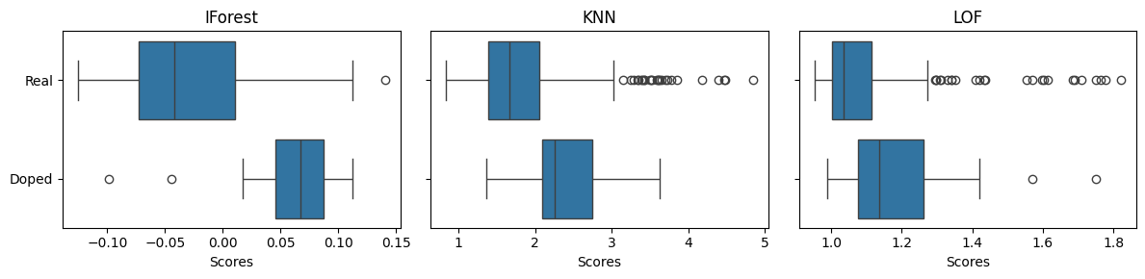
- The box plots reveal distinct differences in anomaly score distributions across real data and doped data for different outlier detectors (IForest, KNN, and LOF).
- IForest demonstrated the best performance in detecting outliers among the three models, since its anomaly score of the doped data is significantly higher than the score of real data.
- In the box plot of KNN, it is observed that the rightward shift of the box representing the doped data is smaller compared to that of IForest, suggesting that KNN performs less effectively than IForest in identifying outliers.
- Additionally, the LOF model has the weakest distinction ability, as we can see that it exhibits the smallest difference in anomaly score distributions between the doped and real data.
- Based on the boxplot analysis, IForest shows the best outlier detection performance, followed by KNN and LOF. To further validate this finding, the AUROC score is employed to quantitatively evaluate the performance of the three outlier detectors.
- AUROC is an objective metric for evaluating the performance of outlier detectors in the presence of artificially introduced anomalies, where a higher score indicates better discrimination between normal and anomalous samples.
- The output shows that IForest achieved the highest AUROC score (0.8614), next was KNN (0.7861), and LOF scored the lowest (0.7451). These findings are consistent with the boxplot analysis and further confirm that IForest provides the strongest anomaly detection capability among the three models.
- Therefore, selecting IForest as the primary outlier detection model in this project enhances the reliability of our anomaly identification results.

